High-Level Functional Requirements Specification
for

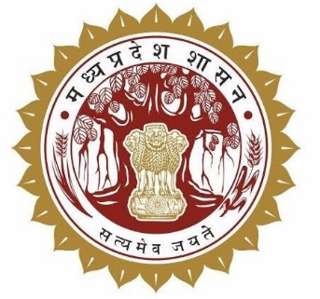

Integrated Composite portal - Jal Rekha



Madhya Pradesh State Electronics  Development Corporation (MPSeDC)  State IT Center, 47-A, Arera Hills,  Bhopal, M.P. – 462011 |  | Prepared for the Public Health Engineering  Department (PHED), Government of Madhya Pradesh  Phone: +91-755-2518300  URL: www.mpsedc.mp.gov.in

High-Level FRS | Document Version 1.0 (Draft) | October 2026

Table of Contents
Table of Contents 2
1. Background 3
2. Brief Scope of Work 3
3. Reference to Existing (Base) System 3
3.1 Existing Components (for reference only) 4
3.2 Reason for Integration into GHAN 2.0 4
4. Integration Requirements 4
Reference screen – Jal Rekha login 5
5. Scope of Work – Functional Requirements 5
FR-01: Unified single User Role Management on Web (30 days) 5
FR-02: Asset Geo-Mapping through mobile app (45 days) 6
FR-03: Web GIS Map (10 days) 7
FR-04: Parinam Module – Tap Connection Mapping & Validation through mobile app (15 days) 7
FR-05: Dhara Module – Supplied Water Quantity (20 days) 8
FR-06: Nirmal Module – Water Quality (15 days) 9
FR-07: Sahbhagita Module – Community Participation (15 days) 9
FR-08: Jal Samadhan – Unified Complaint and Grievance Module (30 days) 9
FR-09: GHAN 2.0 Integration (12 days) 10
7. Stakeholders and Role-wise Access 10
7.1 Stakeholders and User Roles 10
9. Indicative Timeline 12
10. Deliverables 12
11. Requirement Yet to be Shared by Department 12

Document Control

Field | Value
Document Title | Integrated Composite portal - Jal Rekha
Project | Integrated Composite portal - Jal Rekha
Prepared For | Public Health Engineering Department (PHED), Government of Madhya Pradesh
Prepared By | MPSeDC – Business Analysis / Project Team
Base Document | High-Level Functional Requirements Specification – Jalrekha and PHED SVS and GHAN 2.0 Integration (source FRS, Jalrekha PHE)
Version | 1.0

1. Background
The Jal Rekha platform is the Government of Madhya Pradesh water-supply monitoring platform, available as a web application and as a native Android mobile application for Jal Nigam. It is directed by ACS, PHED that a single Jal Rekha System have to be designed which is being integrated with other PHED applications such GHaN (Gramin Handpump Nigrani), Digital PHED and application for SVS.

GHAN 2.0 app has been built on a different technology stack (Flutter), whereas Jal Rekha uses Android as its native technology stack. Therefore, GHAN app will be routed as external app through Jal Rekha. Although GHaN app will be part of composite Jal Rekha System.

2. Brief Scope of Work
This document defines, the overall functional requirements for integrating the different applications in Jal Rekha System.
- Composite Jal Rekha portal – for Jal Nigam & PHED officers & for Citizen
- GHAN 2.0 integration with Jal Rekha
- Integration of Digital PHE with Jal Rekha
- Single User Role Management system and its integration
- Data analysis using AI
- Jal Samadhan – Unified complaint and grievance module for citizens and officers.
Following modules to be made available for PHED SVS similar to MVS
- Nirmal – Water quality (sample collection and testing).
- Parinam – Household tap connection (FHTC) validation, with AI support.
- Dhara – Water quantity (meter reading).
- Asset Mapping – Geo-mapping of SVS assets.
- Sahbhagita – Community participation through Implementation Support Agencies (ISA).

3. Reference to Existing (Base) System
The table below summarises the base systems on which the scope of work in Section 5 is delivered.

3.1 Existing Components (for reference only)
S.No. | Component | Technology | Current Status / Role
1 | Jal Rekha web portal | Angular, & .NET Core | Department login and other PHE department login.
2 | Jal Rekha mobile app | Native Android | Field functions: asset capture, meter reading, sample collection, tap connection validation
3 | GHAN 2.0 web portal | .NET | Target platform for the integrated PHE modules
4 | GHAN 2.0 mobile app | Flutter | Target mobile platform; modules to be integrated here
5 | FHTC Parinam AI feature | AI-assisted validation | Developed in Jal Rekha; to be reused for SVS PHE and GHAN integration

3.2 Reason for Integration into GHAN 2.0
Aspect | Jal Rekha | GHAN 2.0
Mobile technology stack | Native Android | Flutter
Integration consequence | Android screens cannot be reused in Flutter | Modules to be integrated with GHAN 2.0
Interim approach | Redirect user to GHAN app | Receives the redirected user

4. Integration Requirements
These requirements apply across all modules.
- Single technology stack: Jal Samadhan, Nirmal, Parinam, Dhara, Asset Mapping and Sahbhagita are integrated into the GHAN 2.0 project (Flutter), on both mobile and web.
- Interim redirection: until a module is live in GHAN 2.0, Jal Rekha redirects the user to the GHAN 2.0 app / portal for that module.
- Two login types in Jal Rekha: the Jal Rekha department login and the other PHE department login.
- Two user logins for PHE: PHE SVS user and GHAN user.
- AI integration: the FHTC Parinam tap connection AI features developed in Jal Rekha are used in the SVS PHE and GHAN modules.
- Common masters: User Master and Scheme Master are shared, so that role, scheme and village mapping is the same on both platforms.

Reference screen – Jal Rekha login
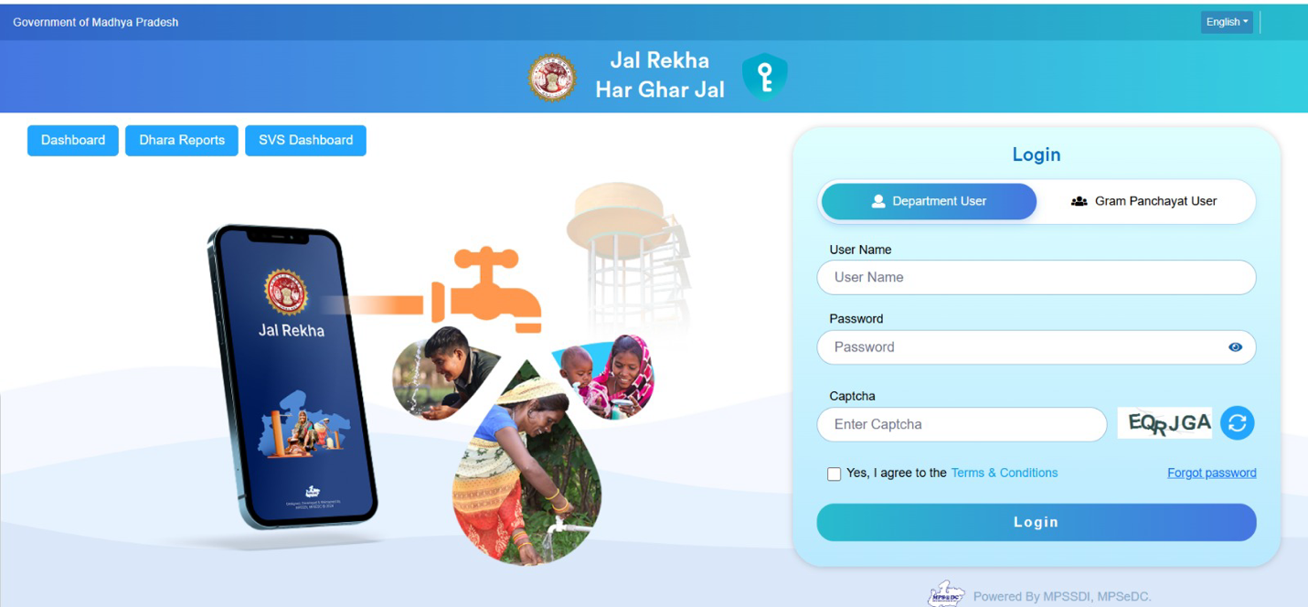
Figure 1: Jal Rekha login page (Department User / Gram Panchayat User)

5. Scope of Work – Functional Requirements

FR-01: Unified single User Role Management on Web (30 days)
- User registration & integration.
- Role-based login for EE, AE, SE, TPI-A, TPI-TL & Contractor with role-appropriate access.
- EE for role/work assignments and validation/approval.
- Role-based menus, dashboards and data visibility (scheme, block, district, division).
- Import of User Master and Scheme Master from other system.
- Audit log of user creation, status changes and scheme assignments.
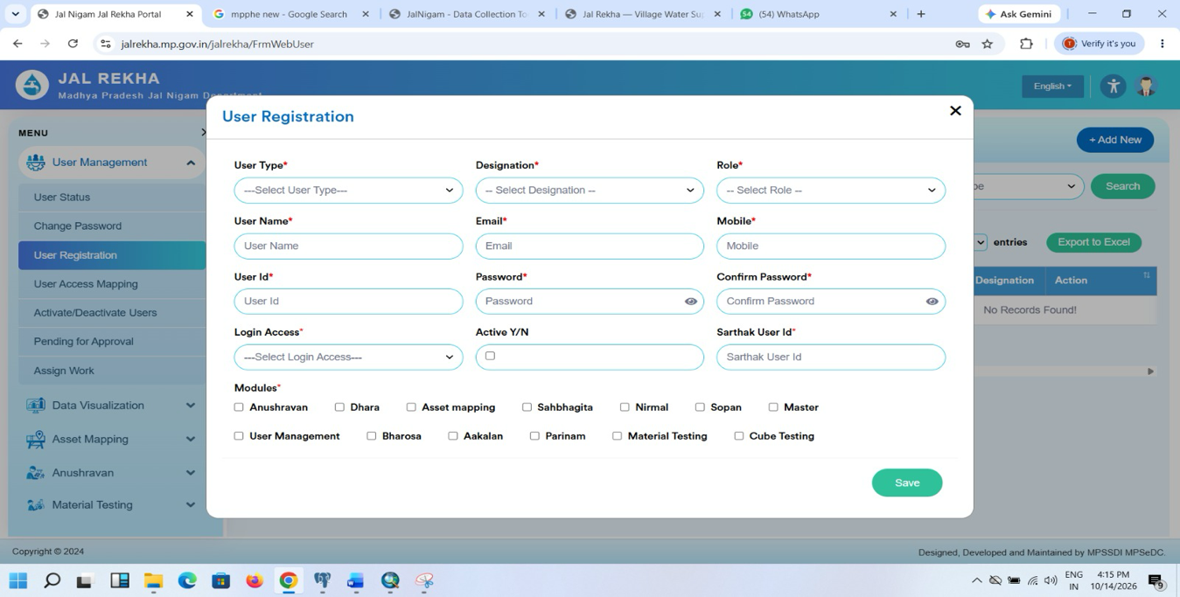

FR-02: Asset Geo-Mapping through mobile app (45 days)
- Display and maintain already-mapped assets such as distribution pipeline, OHT (overhead tank) and tubewell.
- Enable mapping of other assets such as sump well and pump line.
- Asset upload facility in the web portal.
- Capture asset geo-location and attributes through the mobile app.
- Link every asset to its scheme and village.
- Offline and Online mode for users
- Asset mapping report (scheme-wise, district-wise, status-wise: mapped vs pending) on the web application, with export.
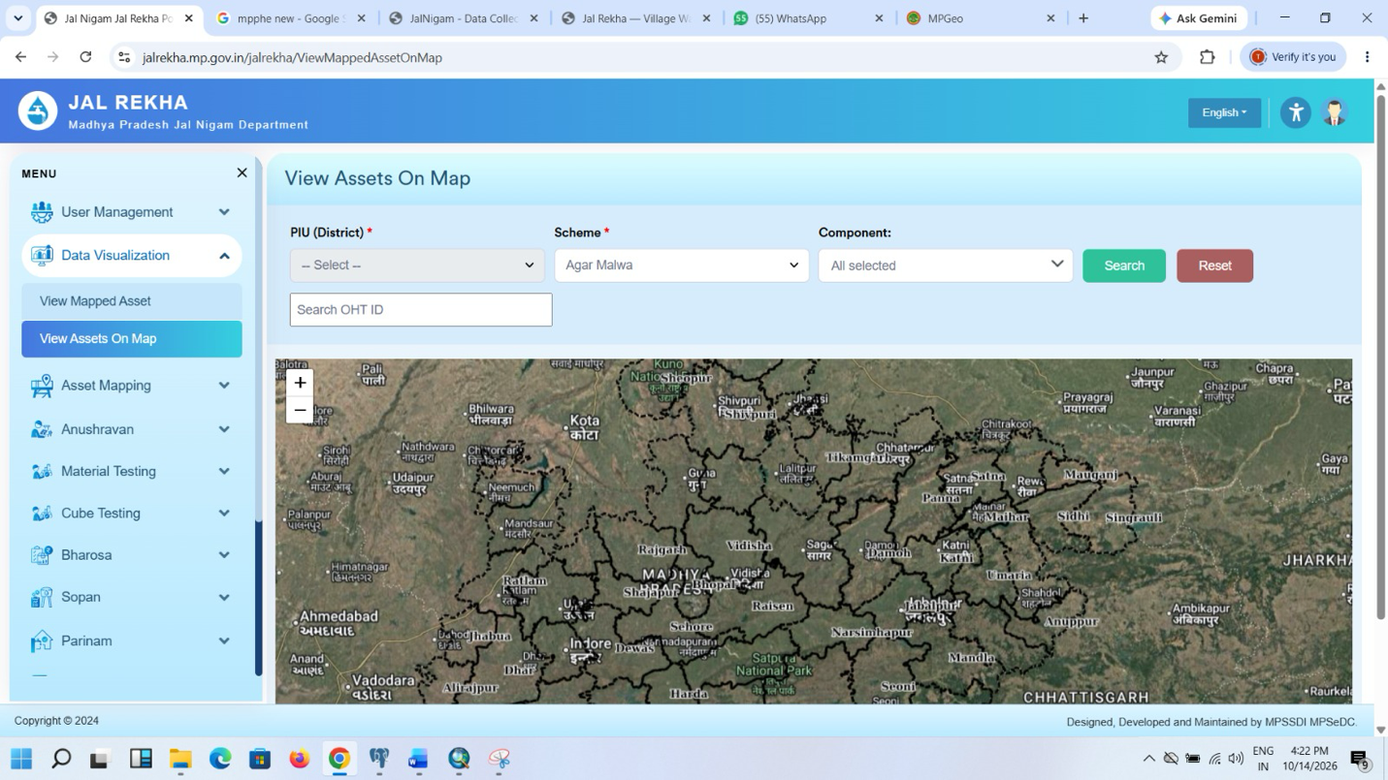

FR-03: Web GIS Map (10 days)
- Scheme-wise and district-wise visualisation of SVS asset data as GIS layer.
- Map and report with drill-down from district to scheme to asset.
- GIS tools such as buffer, proximity, measurement, kml upload etc.

FR-04: Parinam Module – Tap Connection Mapping & Validation through mobile app (15 days)
- Mobile app function to validate household tap connections in the field,
- AI integration for identification of geotagged photos and validation.
- Integration with Samagra ID (Aadhar based eKYC) for beneficiary / user identification.
- Different Reports as per scheme, village and district.
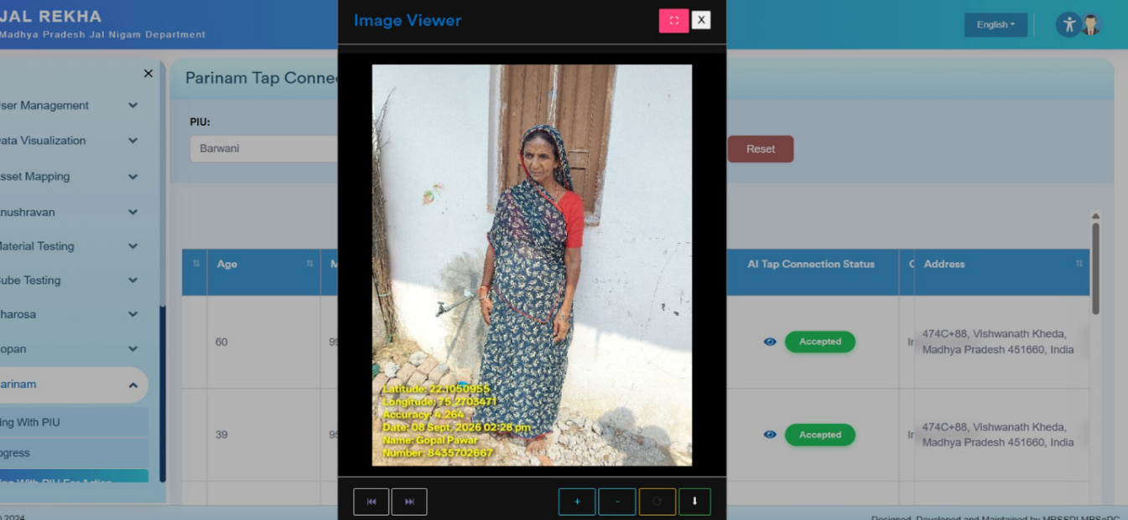

FR-05: Dhara Module – Supplied Water Quantity (20 days)
- Customized Dhara module for SVS.
- Meter reading entry with geotagged photo.
- Validation of readings by concerned officers.
- Web reports on consumption and reading status.
- Integration this validated data for generation of bills for GP’s etc.
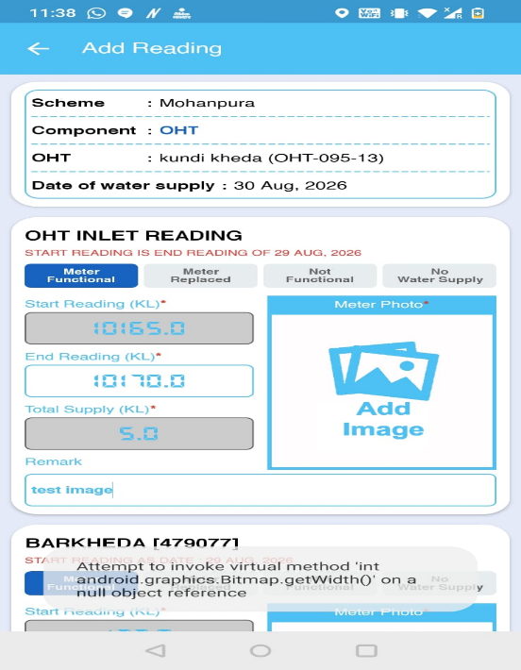

FR-06: Nirmal Module – Water Quality (15 days)
- Water sample testing for SVS and handpump/PWSS.
- Geofenced sample collection.
- Sample collection from OHT, Tubewell and Beneficiaries.
- Web reports on sample and test status.
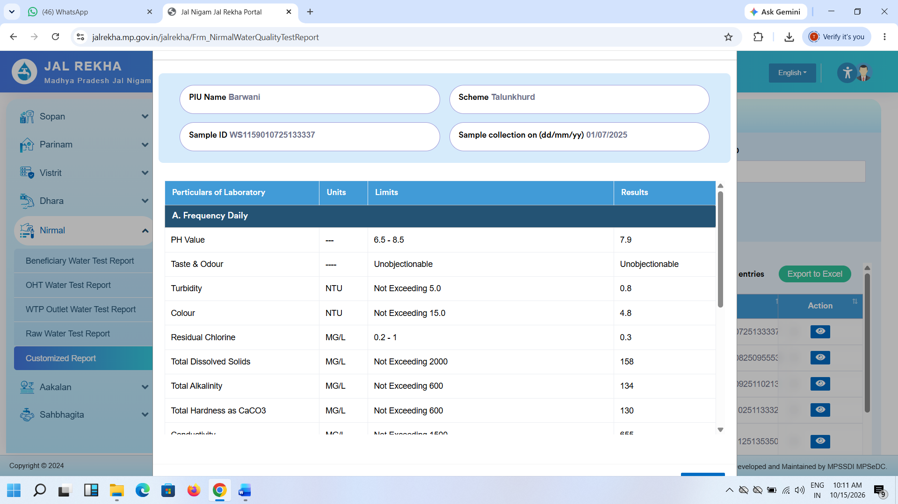

FR-07: Sahbhagita Module – Community Participation (15 days)
- Onboarding all SVS schemes for community participation activities.
- Activity monitoring and reports by ISA.
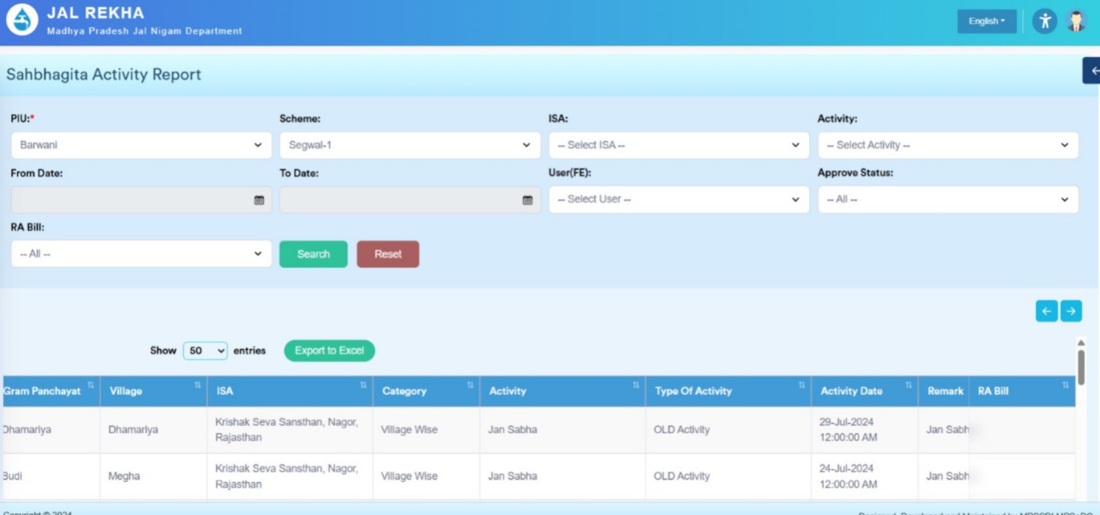

FR-08: Jal Samadhan – Unified Complaint and Grievance Module (90 days)
- Geofenced complaints lodging by citizens through smart mobile phone.
- Geofenced complaints resolution
- Complaints status
- Map and Routing for officers to reach the location
- Integration with CM Helpline & other modules of Jal Rekha & GHaN app
- OTP based logins for citizens.
- Auto assign of complaints.
- Real-time status tracking for the citizen, with SMS or WhatsApp notifications at registration, assignment and closure.
- Citizen feedback on closure, with the option to reopen a complaint.
- Time-bound, level-wise escalation
- Dashboards for the ACS, MPJN, Engineers-in-Chief, SE, EE and AE covering complaints received, pending, resolved, escalated and breaching the timeline.
- Reports by district, scheme, asset type, channel, category and officer; export to Excel and PDF.

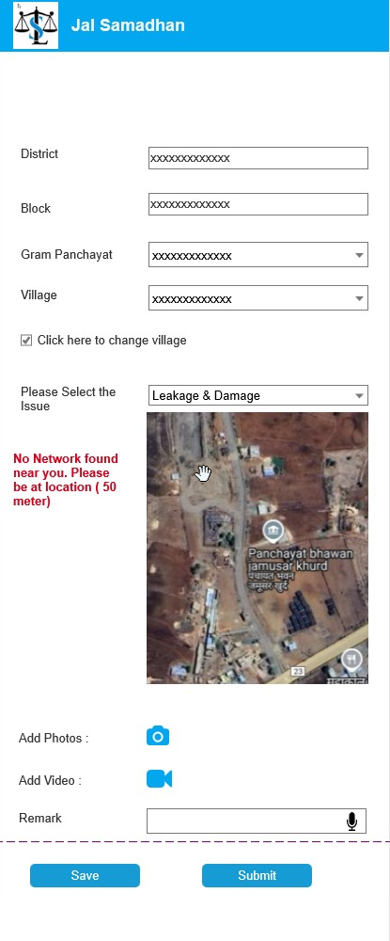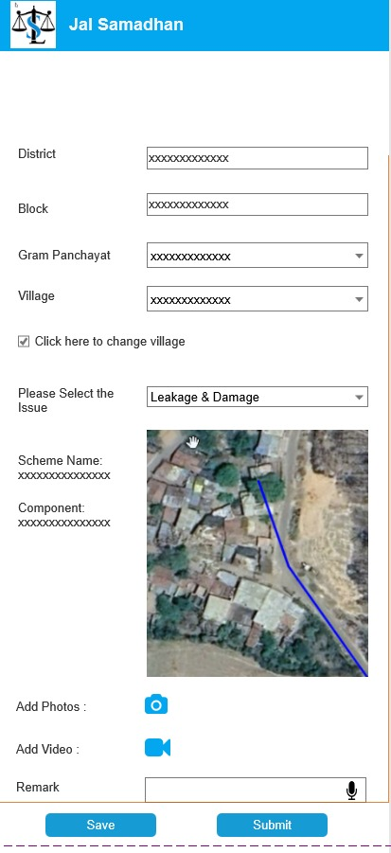

FR-09: GHAN 2.0 Integration (12 days)
- GHAN2.0 application integration with the Jal Rekha app (redirection from Jal Rekha to GHAN).

6. Stakeholders and Role-wise Access

7.1 Stakeholders and User Roles
Role | Description | Access Channel
EE (Executive Engineer) | Administers schemes and users | Web
AE | Monitoring and supervision | Web and Mobile
SE | Field-level supervision, asset and validation review | Web and Mobile
TPIA / TL | Third-party inspection agency staff and team leads | Web (to be confirmed – see Section 11)
ISA | Implementation Support Agency (Sahbhagita module) | Web and Mobile
Citizen | Raises and tracks complaints (Jal Samadhan) | Mobile (OTP login)
ACS, Engineers-in-Chief | Monitoring dashboards and escalation (Jal Samadhan) | Web

7. Indicative Timeline
Effort summary (working days of development effort):
S.No. | Module | Effort (days)
1 | User Role Management | 30
2 | Asset Geo-Mapping through mobile app | 45
3 | Web GIS Map | 10
4 | Parinam | 15
5 | Dhara | 20
6 | Nirmal | 15
7 | Sahbhagita | 15
8 | Jal Samadhan | 90
9 | GHAN 2.0 Integration | 12
 | Total effort | 252

8. Estimated Cost of Project
Integrated Composite Portal - Estimation Cost
S. NO | Resource Type  Development & Support Team | Year wise Resource Count | Project Duration  (12 Month) | Annual  CTC  (INR) | Monthly CTC  (INR) | Cost to department  (INR) | Remark
1 | Project Manager | 0 | 12 | 2800000 | 233333 | 0 | Shared Resources
2 | Sr. Business Analyst | 1 | 12 | 1600000 | 133333 | 1600000
3 | Database Developer | 1 | 12 | 1000000 | 83333 | 1000000
4 | Mobile Developer | 1 | 12 | 1000000 | 83333 | 1000000
5 | Dot Net Developer | 1 | 12 | 1000000 | 83333 | 1000000
6 | Testing Engineer | 1 | 12 | 1000000 | 83333 | 500000 | 50% Salary Allocation – Shared Resources
7 | UI/UX | 1 | 12 | 1000000 | 83333 | 500000 | 50% Salary Allocation – Shared Resources
 |  | 6
A | Total (A) |  |  |  |  | 5600000
B | HR Expenses |  |  |  |  | 223500
C | Total (B) |  |  |  |  | 5823500
B | MPSEDC Service Charges @5% |  |  |  |  | 291175
C | Contingency Charges @5% |  |  |  |  | 291175
D | Total (B) |  |  |  |  | 6405850
E | GST @ 18 % |  |  |  |  | 1153053
F | Grand Total |  |  |  |  | 7558903

*The Cost of SSL /Security Audit / SMS/ E-sign and WhatsApp is not considered in proposal and if applicable shall be as per actuals.

Payment Plan/Milestone
S.No. | Payment Milestone | % of Amount | Total Amount (INR) (With GST)
1 | Advance for Project Initiation | 50% | 3779451.50
2 | UAT of Web Portal and Mobile APP- Development & API Integration | 30% | 2267670.90
3 | Go live of all Modules | 20% | 1511780.60
 |  | 100% | 7558903.00

9. Deliverables
- Jal Rekha SVS modules
- Integrated of GHAN 2.0
- Reports and dashboards.
- Integrated Unified Single Jal Rekha System.

10. Requirement Yet to be Shared by Department
- User Master, Scheme Master and API’s.
- Scheme-wise ISA list for Sahbhagita.
- The Jal Samadhan escalation matrix and timelines.

11.MPSEDC & MP PHE Department Details:

Contact Person

The following professionals have been nominated as the key point of contact for this project.

From MP PHE: -  Name of the Person:  Designation:  Contact No:  Email Address: | From MPSEDC: -  Name of the Person: Dr. Rakesh Dubey  Designation: Head – MPSSDI  Contact No: 085279589815  Email Address: rakesh.dubey1@mpsedc.mp.gov.in

